Feb 22nd

From yesterday 721

Winnings = - 50 + 25+ 5+ (-100) + 55+20 + 22.22+(-20) = -43.something

Total revenue 678

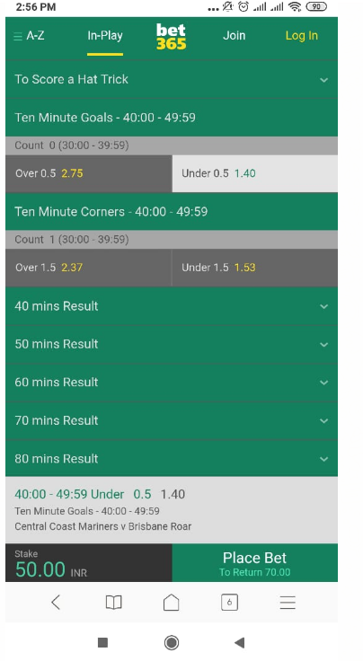

Lost 50

Ten minute goals under .5 -40 min to 49.59 mins

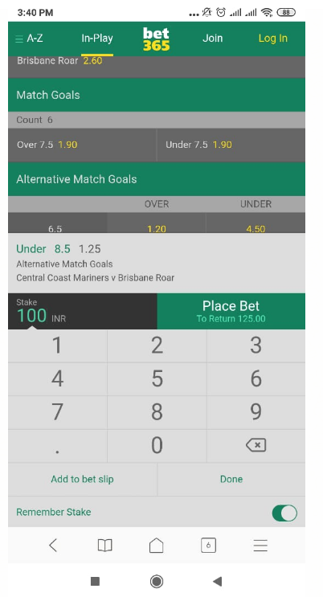

Won 25

Central coast vs Brisbane under 8.5 goals



Won 5

Mohammedan Dhaka vs sheikh Jamal under 3.5 goals

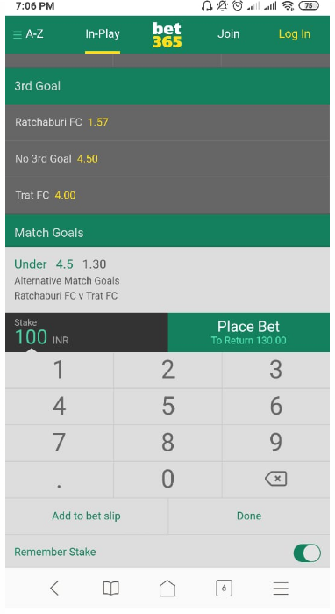

Lost 100

Ratchaburi vs trat under 4.5 goals

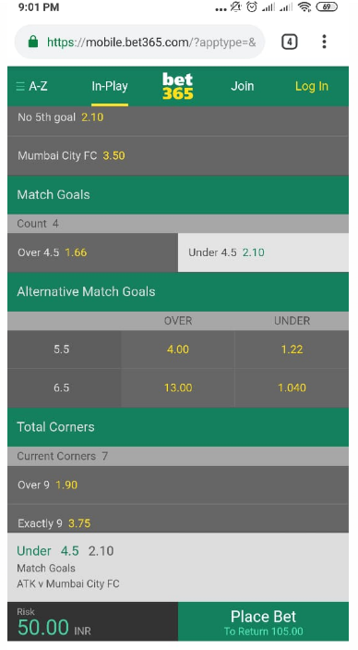

Won 55

ATK vs Mumbai city FC under 4.5 goal



Won 20

Aalen vs sonnenhof under 3.5 goals

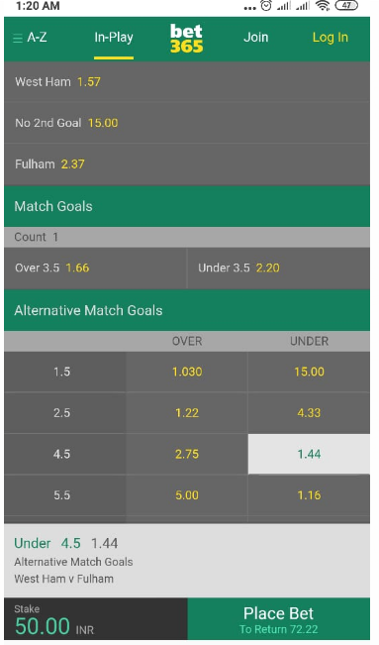

Won 22.22

Westham vs Fulham under 4.5 goals

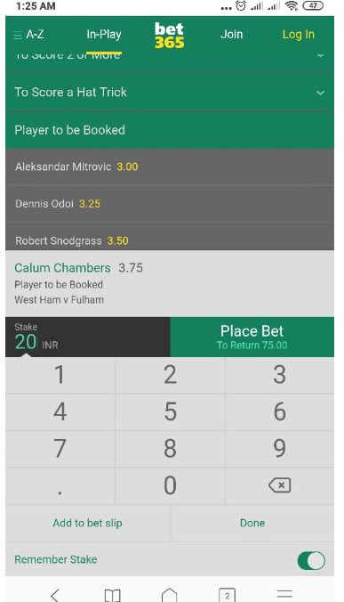

Lost 20

Westham vs Fulham calum chambers booking